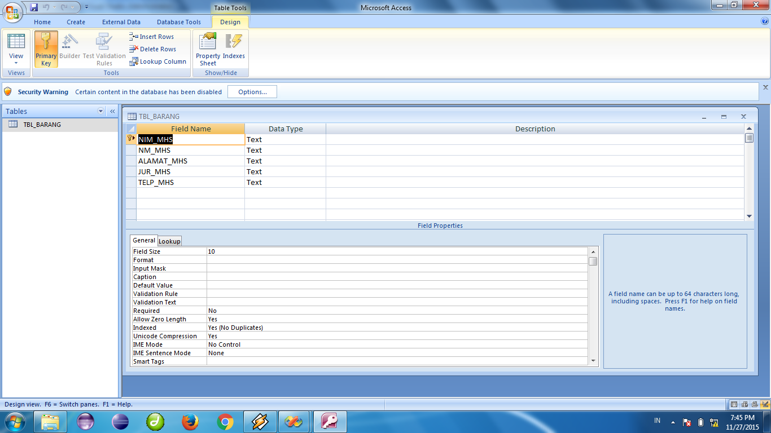

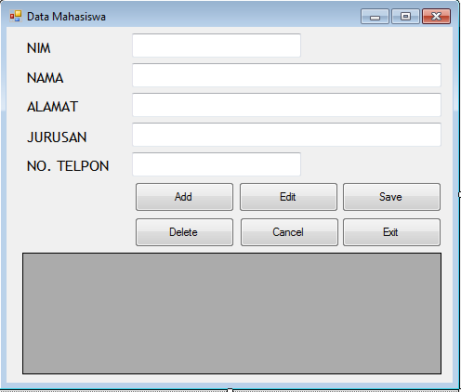

Imports System

Imports System.Data

Imports System.Data.OleDb

Public Class frmMahasiswa

Private strSQL As String

Private objDataTable As DataTable

Private objReader As OleDbDataReader

Private objAdapter As OleDbDataAdapter

Private objDataset As DataSet

Private myCon As OleDbConnection

Private objCommand As OleDbCommand

Private Const strCon As String = "Provider=Microsoft.Jet.OLEDB.4.0; Data Source=C:\Try\MAHASISWA\Mahasiswa.mdb;"

Private Sub LockText()

txtNim.ReadOnly = True

txtAlamat.ReadOnly = True

txtJurusan.ReadOnly = True

txtNama.ReadOnly = True

txtTelpon.ReadOnly = True

End Sub

Private Sub UnLockText()

txtAlamat.ReadOnly = False

txtJurusan.ReadOnly = False

txtNama.ReadOnly = False

txtNim.ReadOnly = False

txtTelpon.ReadOnly = False

End Sub

Private Sub TextKosong()

txtAlamat.Text = ""

txtJurusan.Text = ""

txtNama.Text = ""

txtNim.Text = ""

txtTelpon.Text = ""

End Sub

Private Sub ListGrid()

Try

myCon = New OleDbConnection(strCon)

objDataTable = New DataTable

myCon.Open()

strSQL = "SELECT * FROM TBL_MAHASISWA ORDER BY NIM_MHS ASC"

objCommand = New OleDbCommand(strSQL, myCon)

objReader = objCommand.ExecuteReader(CommandBehavior.Default)

objDataTable.Load(objReader)

grdMahasiswa.DataSource = objDataTable

objCommand.Dispose()

objReader.Close()

objCommand = Nothing

objReader = Nothing

myCon = Nothing

Catch ex As Exception

grdMahasiswa = Nothing

End Try

End Sub

Private Sub frmMahasiswa_Load(ByVal sender As System.Object, ByVal e As System.EventArgs) Handles MyBase.Load

Try

Call TextKosong()

Call LockText()

Call ListGrid()

btnSave.Enabled = False

btnCancel.Enabled = False

Catch ex As Exception

End Try

End Sub

Private Sub btnAdd_Click(ByVal sender As System.Object, ByVal e As System.EventArgs) Handles btnAdd.Click

Call UnLockText()

Call TextKosong()

txtNim.Focus()

btnAdd.Enabled = False

btnEdit.Enabled = False

btnDelete.Enabled = False

btnExit.Enabled = False

btnSave.Enabled = True

btnCancel.Enabled = True

End Sub

Private Sub btnSave_Click(ByVal sender As System.Object, ByVal e As System.EventArgs) Handles btnSave.Click

If txtNim.Text = "" Then

MsgBox("NIM tidak boleh kosong")

txtNim.Focus()

ElseIf txtNama.Text = "" Then

MsgBox("Nama mahasiswa tidak boleh kosong")

txtNama.Focus()

ElseIf txtAlamat.Text = "" Then

MsgBox("Alamat tidak boleh kosong")

txtAlamat.Focus()

ElseIf txtJurusan.Text = "" Then

MsgBox("Jurusan tidak boleh kosong")

txtJurusan.Focus()

ElseIf txtTelpon.Text = "" Then

MsgBox("Nomor telpon tidak boleh kosong")

txtTelpon.Focus()

Else

myCon = New OleDbConnection(strCon)

Try

myCon.Open()

strSQL = "SELECT * FROM TBL_MAHASISWA WHERE NIM_MHS = '" & Trim(txtNim.Text) & "'"

objCommand = New OleDbCommand(strSQL, myCon)

objReader = objCommand.ExecuteReader(CommandBehavior.Default)

If objReader.HasRows Then

MsgBox("Duplicate Data")

Else

objCommand.Dispose()

strSQL = "INSERT INTO TBL_MAHASISWA (NIM_MHS,NM_MHS,ALAMAT_MHS,JUR_MHS,TELP_MHS) VALUES('" & txtNim.Text & "','" & txtNama.Text & "','" & txtAlamat.Text & "','" & txtJurusan.Text & "','" & txtTelpon.Text & "')"

objCommand = New OleDbCommand(strSQL, myCon)

If objCommand.ExecuteNonQuery Then

MsgBox("Data telah di simpan")

Else

MsgBox("Data error di simpan")

End If

objReader.Close()

End If

Catch ex As Exception

MsgBox("ERROR : " & ex.Message)

Finally

myCon.Close()

objCommand = Nothing

objReader = Nothing

myCon = Nothing

Call ListGrid()

Call LockText()

Call TextKosong()

btnAdd.Enabled = True

btnEdit.Enabled = True

btnDelete.Enabled = True

btnExit.Enabled = True

btnSave.Enabled = False

btnCancel.Enabled = False

End Try

End If

End Sub

Private Sub btnCancel_Click(ByVal sender As System.Object, ByVal e As System.EventArgs) Handles btnCancel.Click

Call TextKosong()

Call LockText()

btnAdd.Enabled = True

btnEdit.Enabled = True

btnDelete.Enabled = True

btnExit.Enabled = True

btnSave.Enabled = False

btnCancel.Enabled = False

btnEdit.Text = "Edit"

End Sub

Private Sub btnDelete_Click(ByVal sender As System.Object, ByVal e As System.EventArgs) Handles btnDelete.Click

If txtAlamat.Text = "" Or txtJurusan.Text = "" Or txtNama.Text = "" Or txtNim.Text = "" Or txtTelpon.Text = "" Then

MsgBox("Data kosong")

Else

myCon = New OleDbConnection(strCon)

Try

myCon.Open()

strSQL = "DELETE FROM TBL_MAHASISWA WHERE NIM_MHS = '" & Trim(txtNim.Text) & "'"

objCommand = New OleDbCommand(strSQL, myCon)

If objCommand.ExecuteNonQuery Then

MsgBox("Data telah dihapus")

Else

MsgBox("Hapus data gagal")

End If

Catch ex As Exception

MsgBox("ERROR : " & ex.Message)

Finally

myCon.Close()

objCommand = Nothing

objReader = Nothing

myCon = Nothing

Call ListGrid()

Call TextKosong()

Call LockText()

End Try

End If

End Sub

Private Sub btnEdit_Click(ByVal sender As System.Object, ByVal e As System.EventArgs) Handles btnEdit.Click

If txtAlamat.Text = "" Or txtJurusan.Text = "" Or txtNama.Text = "" Or txtNim.Text = "" Or txtTelpon.Text = "" Then

MsgBox("Data kosong")

Else

If btnEdit.Text = "Edit" Then

btnEdit.Text = "Update"

btnAdd.Enabled = False

btnEdit.Enabled = True

btnSave.Enabled = False

btnDelete.Enabled = False

btnCancel.Enabled = True

btnExit.Enabled = False

Call UnLockText()

txtNim.ReadOnly = True

txtNama.Focus()

Else

myCon = New OleDbConnection(strCon)

Try

myCon.Open()

strSQL = "UPDATE TBL_MAHASISWA SET NM_MHS = '" & txtNama.Text & "', ALAMAT_MHS = '" & txtAlamat.Text & "', JUR_MHS = '" & txtJurusan.Text & "', TELP_MHS = '" & txtTelpon.Text & "' WHERE NIM_MHS = '" & txtNim.Text & "'"

objCommand = New OleDbCommand(strSQL, myCon)

If objCommand.ExecuteNonQuery Then

MsgBox("Data telah diupdate")

Else

MsgBox("Update data gagal")

End If

Catch ex As Exception

MsgBox("ERROR : " & ex.Message)

Finally

myCon.Close()

objCommand = Nothing

objReader = Nothing

myCon = Nothing

Call ListGrid()

Call TextKosong()

Call LockText()

End Try

btnEdit.Text = "Edit"

btnAdd.Enabled = True

btnEdit.Enabled = True

btnDelete.Enabled = True

btnExit.Enabled = True

btnSave.Enabled = False

btnCancel.Enabled = False

End If

End If

End Sub

Private Sub btnExit_Click(ByVal sender As System.Object, ByVal e As System.EventArgs) Handles btnExit.Click

Me.Close()

End Sub

Private Sub grdMahasiswa_Click(ByVal sender As Object, ByVal e As System.EventArgs) Handles grdMahasiswa.Click

Try

Try

txtNim.Text = Trim(grdMahasiswa.SelectedCells(0).Value)

txtNama.Text = grdMahasiswa.SelectedCells(1).Value

txtAlamat.Text = grdMahasiswa.SelectedCells(2).Value

txtJurusan.Text = grdMahasiswa.SelectedCells(3).Value

txtTelpon.Text = grdMahasiswa.SelectedCells(4).Value

Catch ex As Exception

End Try

Catch ex As Exception

End Try

End Sub

End Class